Figures Appendix
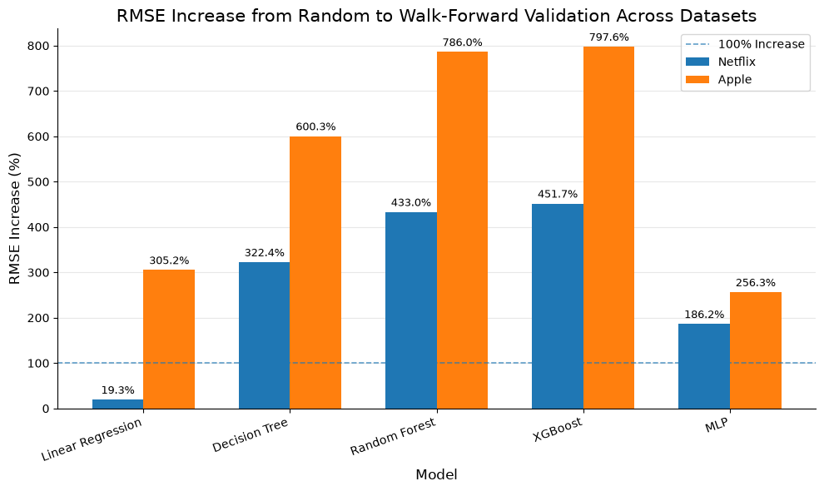

Figures from experimentation on Apple Stock:
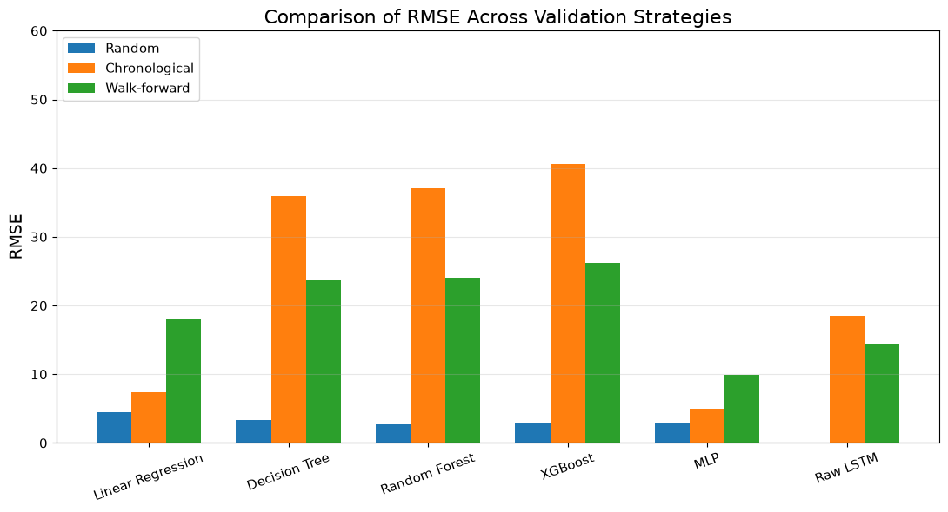
Figure 1: Comparison of RMSE Across Validation Strategies
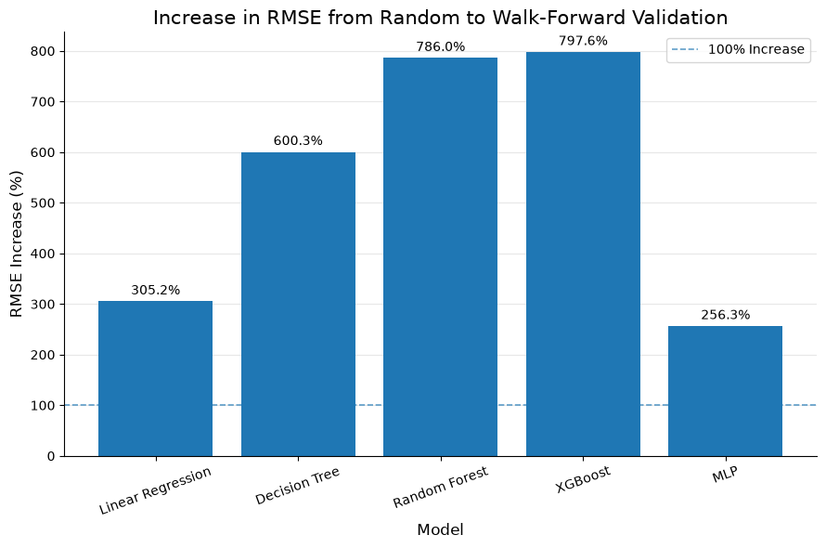
Figure 2: Increase in RMSE from Random to Walk-Forward Validatio
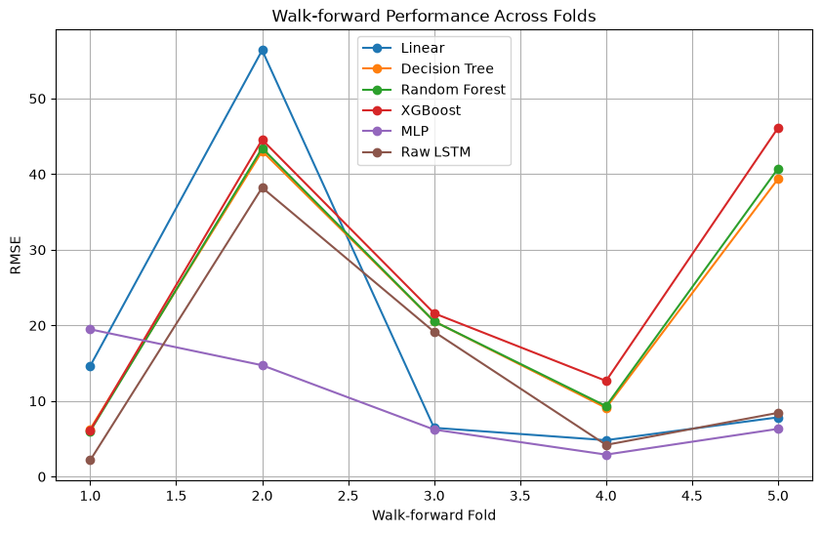
Figure 3: Walk-forward Performance Across Folds

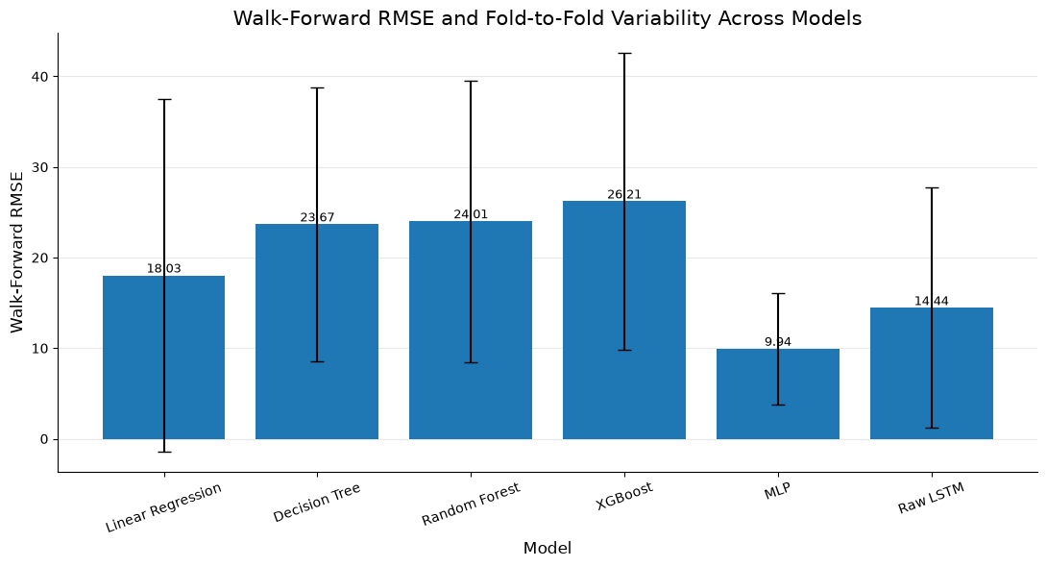
Figure 4: Walk-Forward RMSE and Fold-to-Fold Variability Across Models
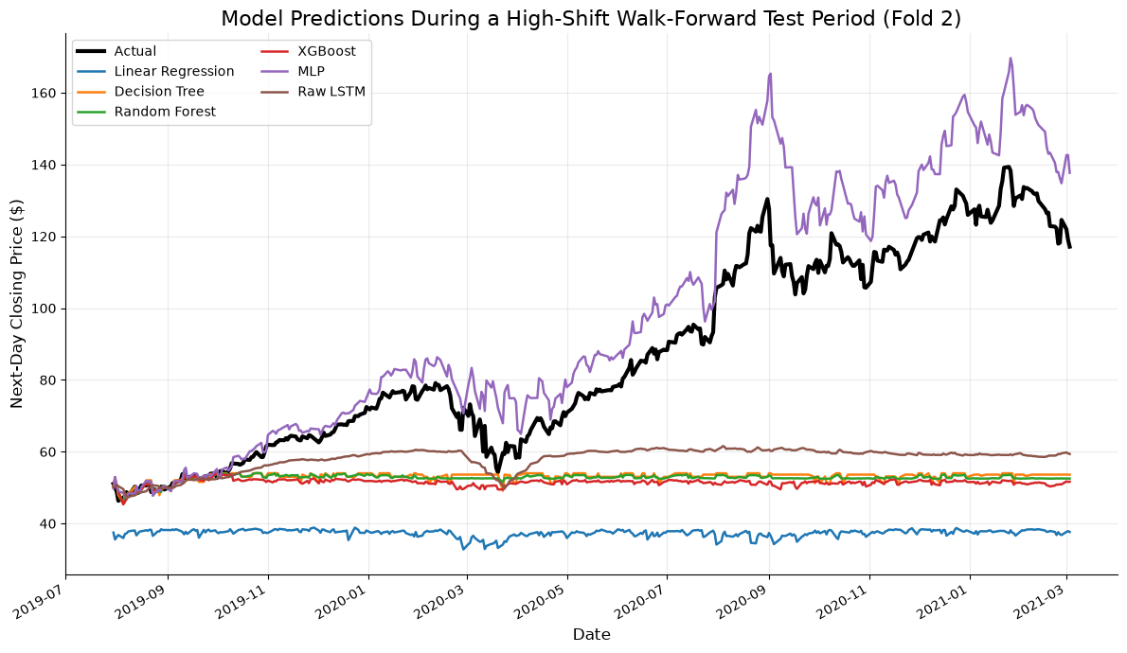
Figure 5: Model Predictions During a High-Shift Walk-Forward Test Period (Fold 2)

Figures from experimentation on Netflix Stock:
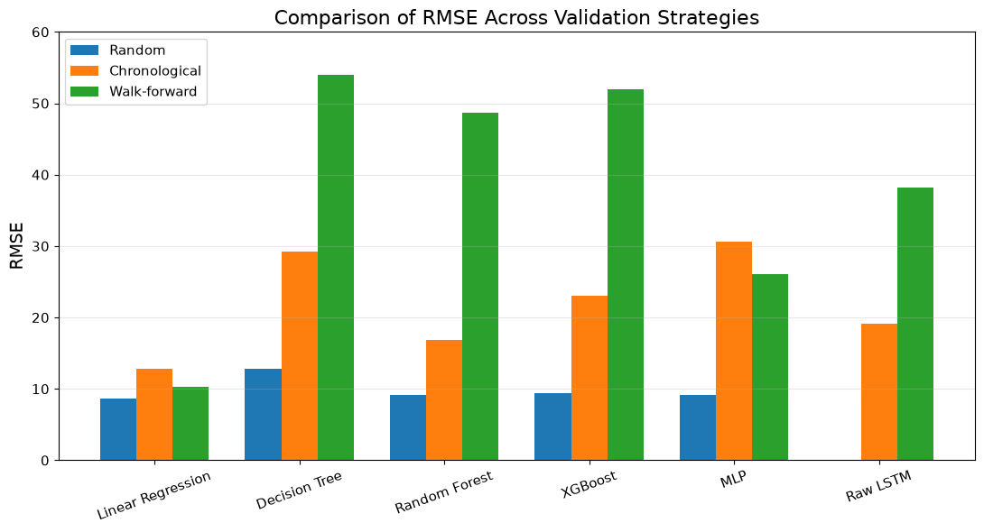
Figure 1: Comparison of RMSE Across Validation Strategies
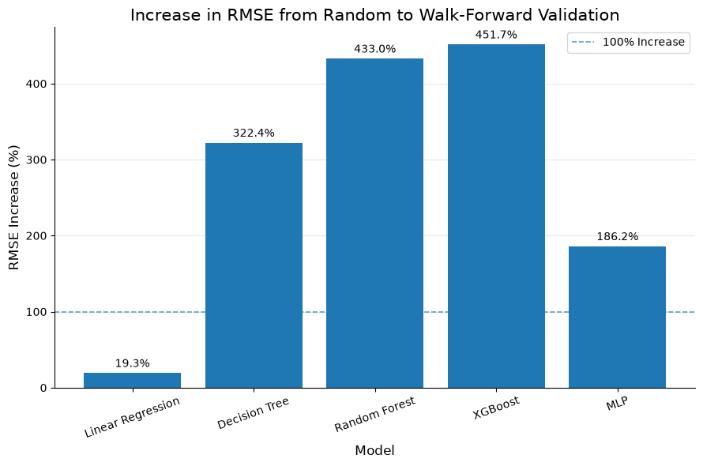
Figure 2: Increase in RMSE from Random to Walk-Forward Validation
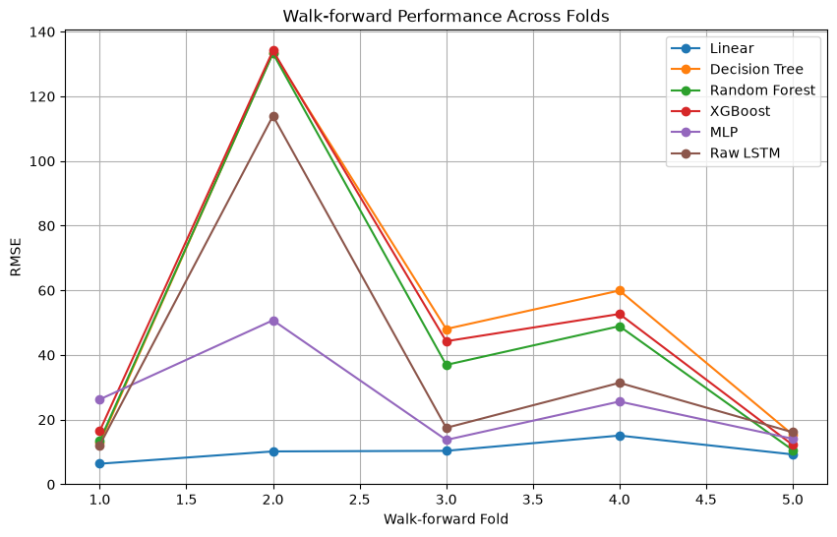
Figure 3: Walk-forward Performance Across Folds

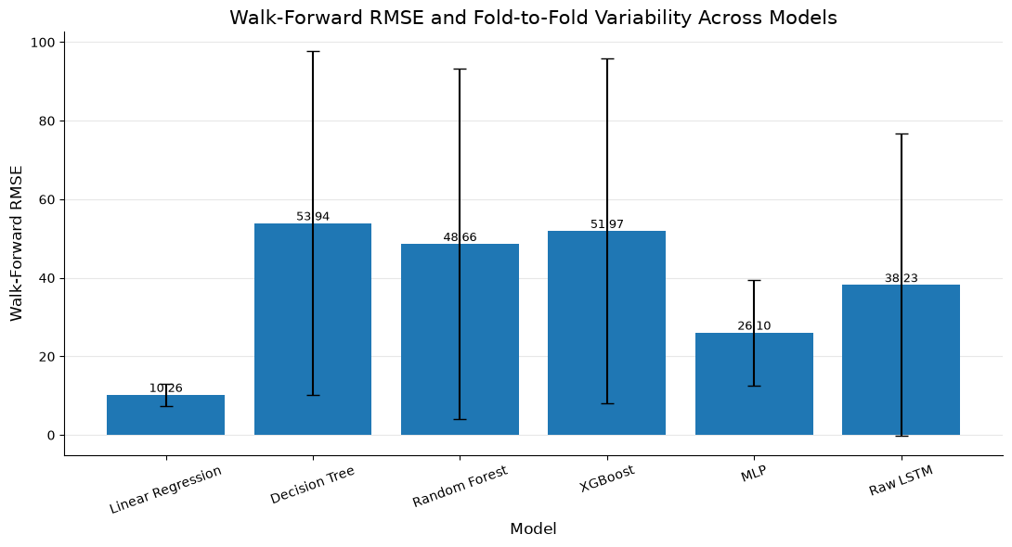
Figure 4: Walk-Forward RMSE and Fold-to-Fold Variability Across Models
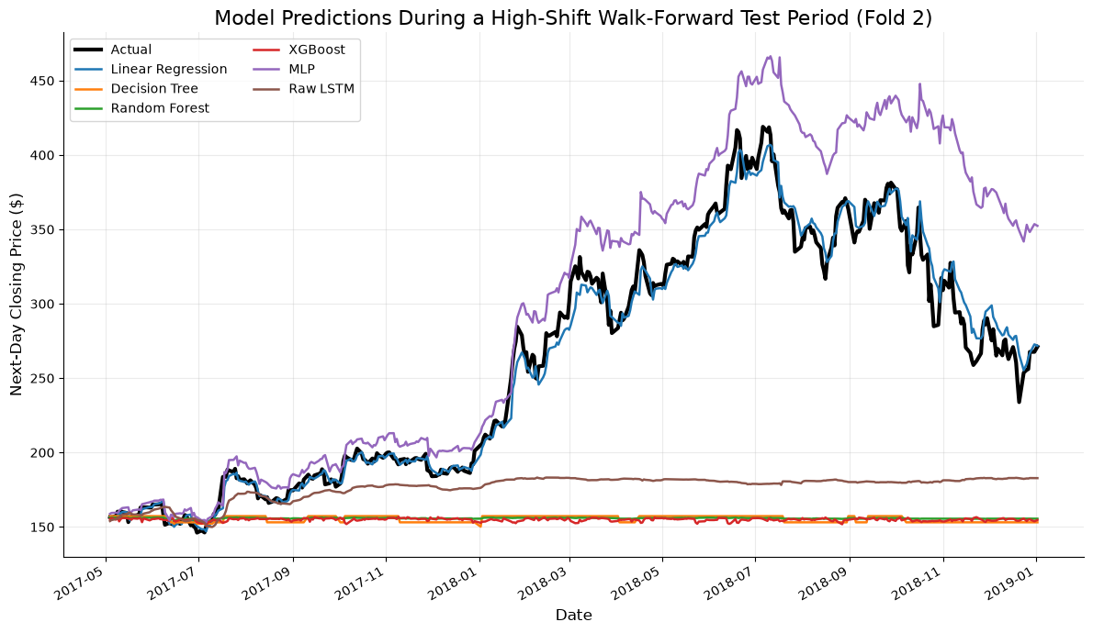
Figure 5: Model Predictions During a High-Shift Walk-Forward Test Period (Fold 2)

